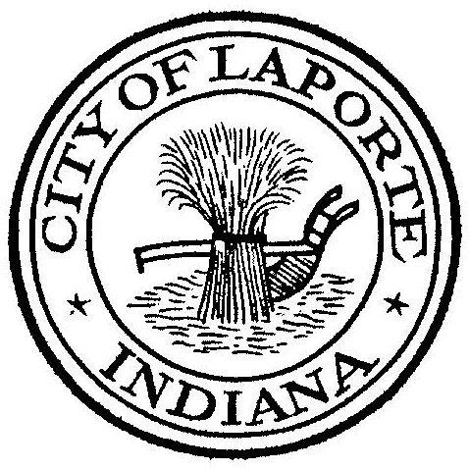
Board of Public Works and Safety
Jessica Romine, Member Tom Dermody, Mayor Mark Kosior, Member
City Hall 801 Michigan Ave., La Porte, IN 46350
Thursday, October 20, 2022
10:00 AM
AGENDA
- Call To Order
- Pledge Of Allegiance
- Approval Of Minutes
- Public Comment: In Person and via Facebook Live
- Clerk-Treasurer: Claims Approval
- New Business:
-Paul Brettin: Retirement Letter and Request to Hire
-Jerry Jackson: La Porte Phosphorus Pay Request No. 6
-Nick Minich: Refuse and Yard Waste Collection and Disposal Service Contract Request
8) Unfinished Business:
9) Other Business: Next Meeting will be on Wednesday, November 9, 2022 at 9:00am due
to Election Day on Tuesday, November 8, 2022

